Pre-publishing DRAFT Revised Jan 14, 2024 8:14 am

Orchid ID: 0000-0002-2295-0272
https://doi.org/10.13140/RG.2.2.12676.30083

An Implantable Power Generator

Timm A. Vanderelli

Independent Research and Development at Ferrocell USA, Ligonier, PA 15658 USA

E-mail: tvan@ferrocell.us

January 11, 2024

Abstract

In this paper, I describe an electric power generator and show a functional prototype which is small enough to be implanted into the human body, shaped to fit into the area below the lungs, affixed to the interior body cavity and activated by the slow, rhythmic movement of the diaphragm. The average adult human diaphragm will move more than fifty-millimeters during the involuntary breathing process, such as while a body is at rest or sleeping. During this minimum breathing period, the implantable power generator will output a stream of pulsed electric current with each inhale and another stream of pulsed electric current from each exhale during the slow rate of diaphragm motion. Considerably more energy can be produced by the implantable power generator while walking, excited or during physical activity due to the increased travel of the body's diaphragm when the lungs process a greater amount of air. The power generator shown here has sufficient output energy to supply a pacemaker, implantable pulse generator or other medical implants that require a constant supply of power. This device eliminates the need for internal batteries that require repeated surgeries due to their constant replacement or wireless charging using radio frequency waves inductively coupled through the skin, which poses a health concern due to the potential for cell damage.
Keywords
Implant Technology, Human Power Generation, Electromagnetism.

1. History

A number of methods have been tried in attempts to generate electric currents from the human body to provide practical power for implants. One internal method is the use of micro-generators within the arteries creating “vascular turbines¹". The micro-turbine method produces very little power but may be usable for implants that require very low amounts of energy. Another method harvests a few microwatts from the beating of the heart using piezoelectricity², of which provides supplemental power to energize a pacemaker, but does not generate enough energy on its own to sustain the pacemaker for its long-term operation. These forementioned methods are experimental, not yet ready for medical use and produce little usable energy. Practical energy has always been obtained from the chemical battery. Older technologies include rechargeable, exo-body, battery packs³ where high energy-consuming implants are utilized.
A problem with external battery packs is the region of the body where wires pass from outside the body, through the epidermis and on to the implant. In this example, the epidermis suffers the possibilities of infection or disease along with the inconvenience and discomfort⁴ the recipient experiences while wearing this apparatus. Today's implants require their internal batteries need to be replaced between two to twelve years, depending on the implants power requirements. Currently, the widely accepted method to reduce repeated surgeries is to wirelessly charge an implants internal battery from external chargers through inductive RF coupling⁵, whereby radio waves are transmitted into a first inductor and electromagnetically coupled into a second inductor implanted below the skin, which is designed to be in electromagnetic resonance with said first inductor. Received radio frequencies from said second inductor are then rectified, filtered and regulated for charging the implants battery. The charging wires are usually supported by a small magnet attached to the charger's first inductor that is attracted to the ferrous core of the implant's second inductor, holding it in place. This inductive coupling method is preferred for charging batteries that require low amounts of power to charge. Human cells can be damaged by excessively powered radio frequency waves passing through the skin which results from body tissue heating⁶. The Federal Communications Commission has imposed exposure limits of 4 mW/cm for the general U.S. population in relation to this concern for human health⁷. Additionally, the recipient remains inconveniently tethered to a wire for periods of time while charging their internal device and must always have access to a charging source.

2. Introduction

Thoughts of how to generate useful power from the human body have led to the design, construction and testing of the implantable power generator disclosed here⁸. Safety concerns and design restrictions include minimum friction so recipients with breathing difficulties are not adversely affected from the use of this device. Drag created from the magnets' attraction to the inductors⁹ is overcome by using air cores instead of typical ferrous cores, leaving only weak eddy current loss from the copper wire itself¹⁰. Also, slow-moving magnetic fields typically don't produce much energy. Obtaining useful power from a slow-moving magnetic field is accomplished here by breaking up the magnetic field and the inductors into short segments, then combining all of the magnets and segments into rows and columns. This novel method forms an electromagnetic matrix that produces a stream of pulses each time a group of magnets pass through a group of inductors, even during a slow rate of motion. And finally, determining a safe location and creating a secure adhesion to body muscle and cavity tissue is most important.
A qualified surgeon will need to perform the implant procedure by attaching the implantable power generator to the interior cavity wall and then attaching the activation rod to the body's diaphragm. This procedure ends by guiding the implantable power generator's output wires to the appropriate implant requiring power and closing the incisions.

3. Description

The primary obstacle for this implantable power generator was to overcome the minimal energy obtained from a slow-moving magnetic field. We know from Faraday's law of induction¹¹ that: $E=-N\frac{ΔΦ}{Δτ}$where: $E=induced voltage, N = number of turns, ΔΦ =change in magnetic flux and Δτ=change in time.$ By reducing the rate of time ($∆τ)$ we gain voltage ($E)$. To satisfy this condition, we can pass the magnet through the inductor faster, or the inductor can be made shorter. Since a short inductor can't contain as many windings (N) as a long one, when divided into multiple, series-connected, spaced-apart segments, the column will function as one long inductor and retain its change of magnetic flux ($∆Φ$). Utilizing a matrix of multiple magnets and columns summed together produces a series of pulses of a higher voltage ($E)$ than would normally be generated by using one magnet and one inductor during a slow-moving magnetic induction traveling the same distance, of which will yield a weak, single pulse of voltage. The first prototype described here consists of five small inductors using #40 AWG copper enameled wire, equally separated by their coil width dimension and wound around a thin plastic cylinder as shown in Figure 1, forming a column (two shown). Each inductor has a DC resistance of .5 Ohm and an inductance of 50 mH resulting in a total of 2.5 Ohms DC resistance and 250 mH inductance from each column. Five small ring magnets, with a $Βr$ of 2000 Gauss on each face are fixed onto a thin plastic rod that slides forward and backward inside each plastic column with their magnetic polarities all facing in the same direction. This prototype utilizes six columns, stacked parallel and wired in series with each other for maximum output voltage.
The actuator rods are tied together and made to move in unison by the movement of one flexible rod potentially attached to the body's diaphragm while the encapsulated housing containing columns are potentially affixed to the inner body cavity wall.

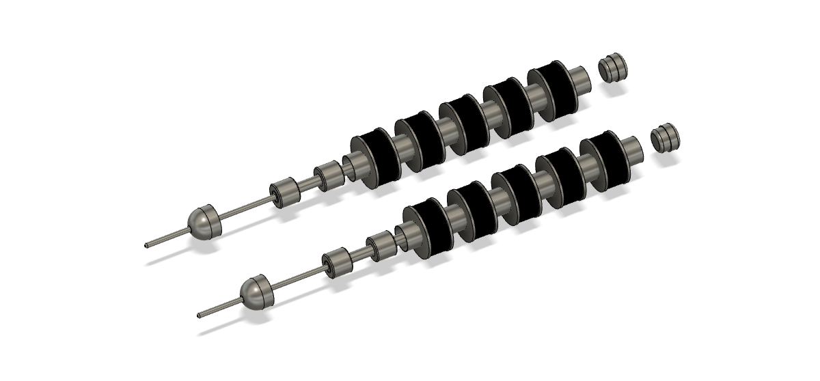
Fig. 1. Two inductor-magnet columns

The use of non-ferrous air-cores results in very little friction or drag. It’s common knowledge that much more energy can be obtained by using ferrous-cored inductors, and they were originally contemplated for this design to make the device smaller and more robust.
However, the magnetic attraction to the ferrous cores creates drag that could inadvertently affect recipients who have trouble breathing already. Air was chosen over ferrous cores in consideration for the physical well-being of these people.

4. Data

Three tests shown here were performed on this implantable power generator to measure its output voltage and current in a physical simulation. In the following tests, the activation rods were slid in and out of the columns for a distance of 25 mm in and 25 mm back out to achieve the results shown here. This is half the distance normally traveled by a body's diaphragm while sleeping or resting. Since the generator output is an AC waveform, means for converting to DC is required to be effective and useful for these tests. Figure 2 shows the typical, basic AC to DC power supply used. A full-wave rectifier, 10 uF filter capacitor and a 100 Ohm load resistor were connected to the implantable power generator's output leads¹².

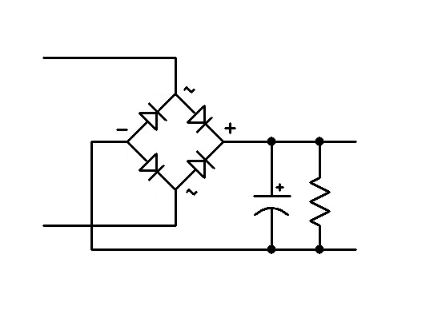
Figure 2

Even though this simple circuit fulfills the test requirements, a more robust and practical rectification and regulation circuit is necessary for medical use. A Supercapacitor would be ideal for storing the generated energy, instead of a chemical rechargeable battery. Figure 3 shows an output voltage and current graph from a six-column matrix, electrically wired in series while actuated together, in-sync with each other. This matrix is potted inside a small, flexible silicon housing. In a first test of one-second duration, a 25 mm stroke of the actuator rods results in an output of 230 mA at 240 mV of DC or 5.52 mJ/S through the 100-ohm resistive load. And in test two, using a general-purpose red LED, an output current of 67 mA at 1.13 Volts or 75.7 mJ/S was measured. This activity resulted in five flashes of the LED during a slow inward stroke and five flashes of the LED during a slow outward stroke, again over a distance of 25 mm in each direction, over a one-second duration. In the final test three, the rectifier-filter circuit shown in Figure 2 was eliminated and only the open-circuit AC voltage was measured from the output of the inductor matrix, reaching a peak-to-peak of six Volts, while sliding the actuator rods a distance of 25 mm, over a duration of one second.
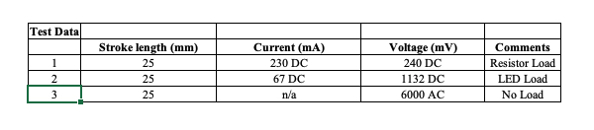
Figure 3

5. Summary

This device is intended to replace batteries that are currently used in medical implants.
The implementation of this generator will enhance the health and safety of implant recipients, by reducing or eliminating the risks and anxiety experienced by repeated surgeries and the inconvenience that these patients now undergo. It will prevent damaged skin from RF charging, eliminate chemical batteries from inside the human body and reduce hazardous waste. Life-long, locally generated power will help bring peace of mind to implant recipients while lowering their overall maintenance costs. One can imagine this device is not limited by connection to the human body's diaphragm but it can be actuated by any other moving, internal muscle of any animal. Likewise, this generator can provide power to other implants that aren't medical in nature but for communication with and control of devices outside the human body¹³. There isn't a limit to the minimum or maximum number of columns of said inductor-magnet matrix, other than the self-imposed limits of the body's cavity volume. This power generator’s matrix design can be scaled to meet the requirements of the chosen device requiring power. For the tests shown above, the columns are all wired in series to obtain maximum voltage. However, other wiring schemes can be used, such as series-parallel or parallel, depending on the voltage and current requirements the implant requiring power. The future of supplying power to implants depends on internally generated energy. After all, the goal is to ensure the human body will work safely and in harmony with implantable technology.

6. References

[1] Magnus Jonsson, A. Zurbuchen, A. Haeberlin, A. Ptenniger, R. Vogel, "Vascular Turbine Powering a Cardiac Pacemaker: an In-vivo Case Study". Experimental & Clinical Cardiology, Vol. 20, Issue 1 (2014).

[2] Andrew Closson, et al. "All-Electrospun Piezoelectric Energy Harvesting for Leadless Pacemakers". ACS Publications, Applied Electronic Materials (2023), https://doi.org/10.1021/acsaeim.3c01152.

[3] Jooli Han, D. Trumble, "Cardiac Assist Devices: Early Concepts, Current Technologies, and Future Innovatioons". Bioengineering (2019), https://doi.org/10.3390%2Fbioengineering6010018

[4] U.S. Food & Drug Administration, Medtronic HeartWare Ventricular Assist Device (HVAD) System. September 22, 2023. https://www.fda.gov/medical-devices/cardiovascular-devices/medtronic-heartware-ventricular-assist-device-hvad-system

[5] National Library of Medicine, Sensors, Sadeque Reza Khan, et al. "Wireless Power Transfer Techniques for Implantable Medical Devices: A Review" (2020). doi: 10.3390/s20123487

[6] National Library of Medicine, Journal Neural Engineering, Stewart Cogan, et al. "Tissue damage thresholds during therapeutic electrical stimulation" (2016). doi: 10.1088/1741-2560/13/2/021001

[7] Federal Communications Commission, "Radio Frequency Safety", https://www.fcc.gov/general/radio-frequency-safety-0

[8] Timm Vanderelli, Implantable Power Generator, US Patent Application Publication, US 2023/0369996 A1, November 16, 2023. https://patents.google.com/patent/US20230369996A1;
Movie of a prototype column with its output connected to an oscilloscope (2021): https://www.ferrocell.us/diaphragm%20generator/pix-movies/tiny_linear_generator.mov

[9] Britannica, Physics, Science & Tech, "Ferromagnetism", November 29, 2023 https://www.britannica.com/science/ferromagnetism

[10] University of Central Florida, University Physics, Vol. 2, "Eddy Currents", 13.5 (2016) https://pressbooks.online.ucf.edu/osuniversityphysics2/chapter/eddy-currents/

[11] Hyperphysics, "Faraday's Law", http://hyperphysics.phy-astr.gsu.edu/hbase/electric/farlaw.html
[12] Timm Vanderelli, Ferrocell USA Ligonier, PA 15658. Video of LED flashing and oscilloscope waveforms with frequency and voltage from a matrix configuration (2021): https://www.ferrocell.us/diaphragm%20generator/pix-movies/tiny_linear_matrix_generator.mov

[13] IEEE, Robert Sobot, "Implantable Technology" [46], January 1, 2019
https://technologyandsociety.org/implantable-technology/

